Bedford Pickleball – Catalogue

‘BPB Mascot’ t-shirt
Printing on left chest and back
Colours available: white, heather grey
£20
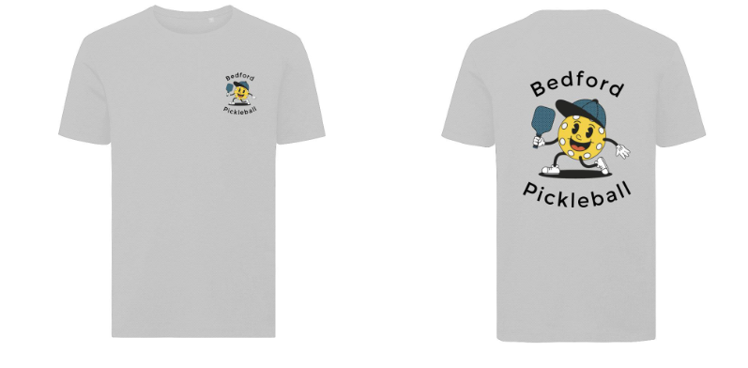
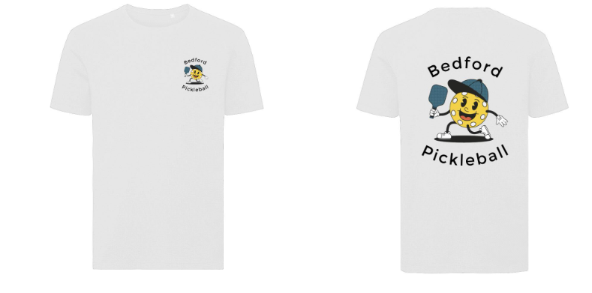

‘BPB Mascot’ sweatshirt
Printing on left chest
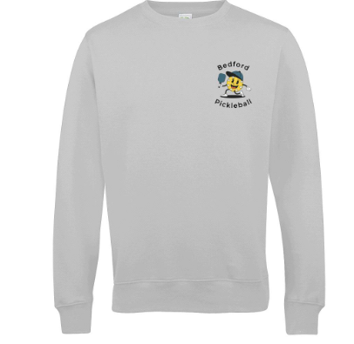
Colours available: heather grey
£30

‘BPB Mascot’ quarter zip sweatshirt
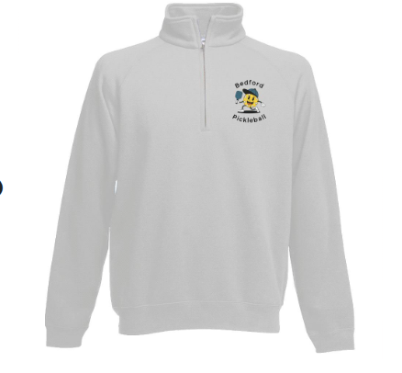
Printing on left chest
Colours available: heather grey
£30

Bedford Pickleball heritage t-shirt
Printing on left chest and back (back print optional)
Colours available: black, navy, heather grey, purple, pink
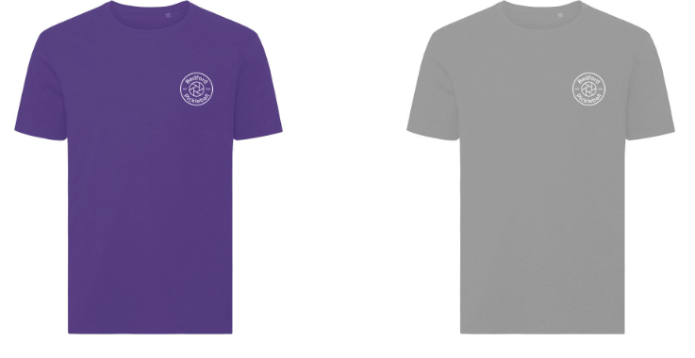
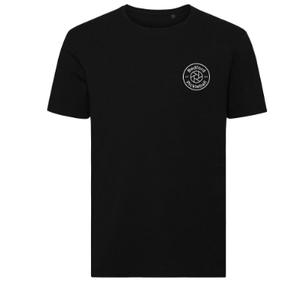
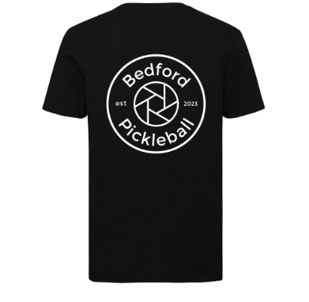
£20

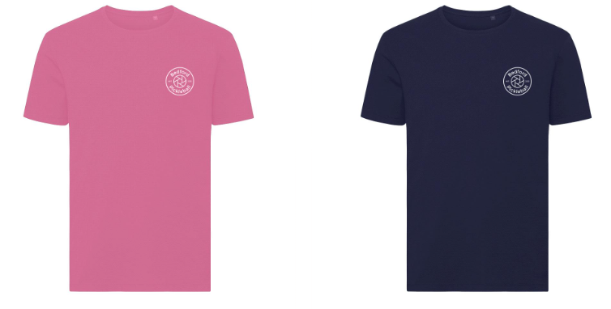

Bedford Pickleball heritage sweater
Printing on left chest (full back print available on request)
Colours available: black, charcoal, dusty green, dusty lilac
£30
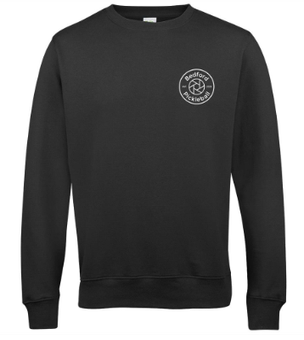
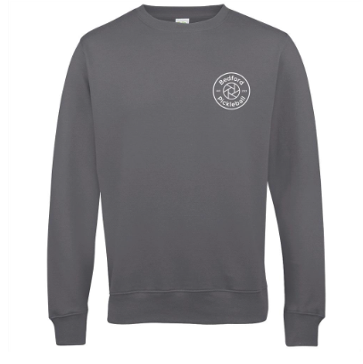

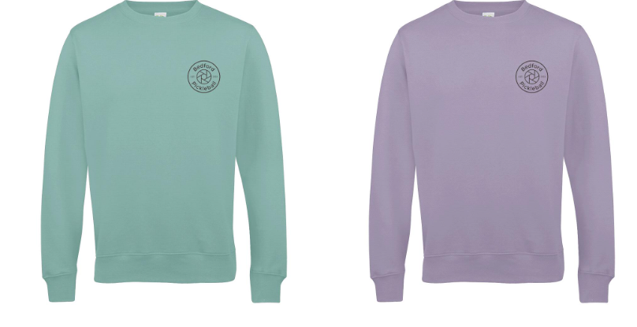
Bedford Pickleball heritage polo
Printing on left chest
Colours available: black, navy, heather grey, purple, pink
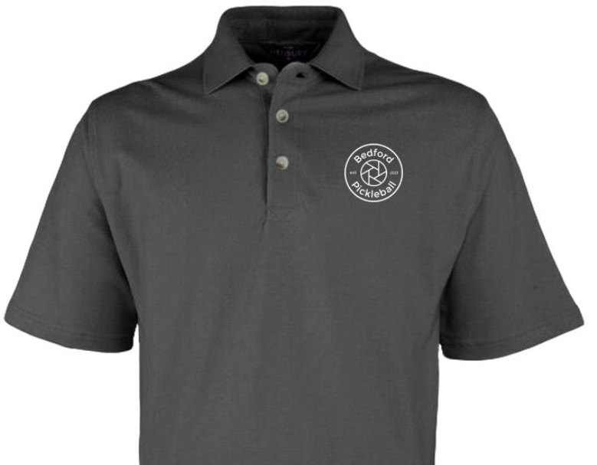
£20
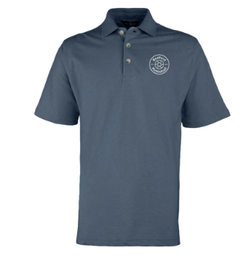

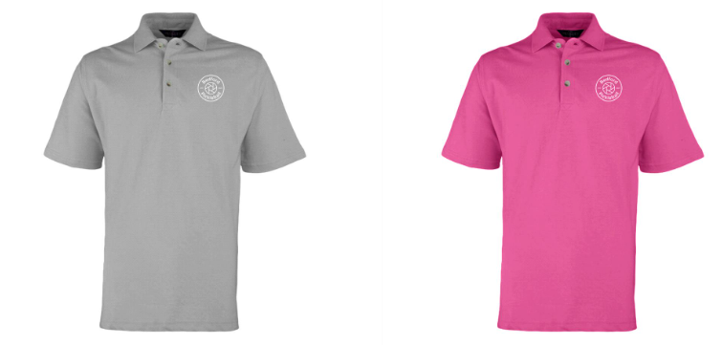
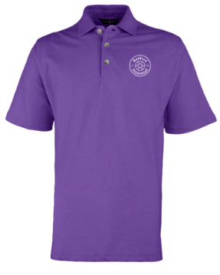

Bedford Pickleball heritage hoodie
Printing on left chest
Colours available: black, pink, mist grey, blue
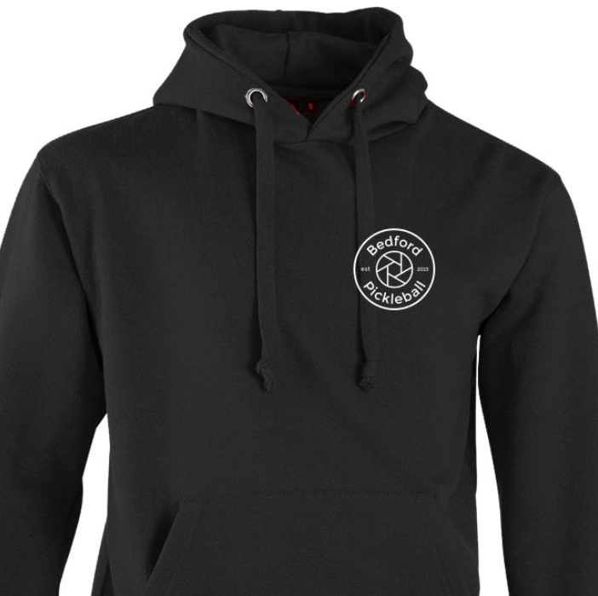
£30

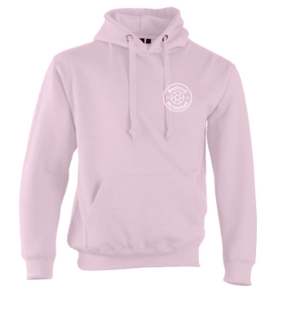

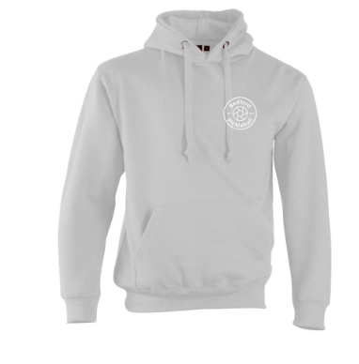
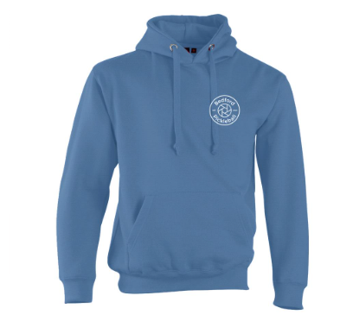

‘Dinking Ultimate Zen’ t-shirt
Printing on left chest and back
Colours available: black
£20
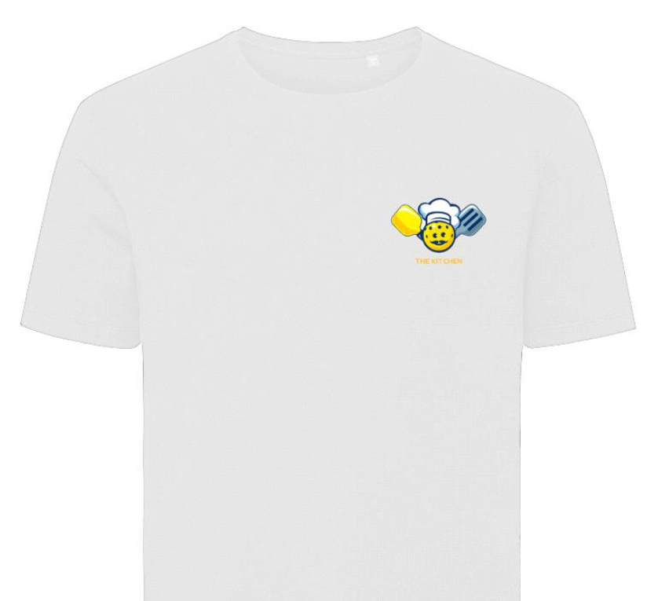
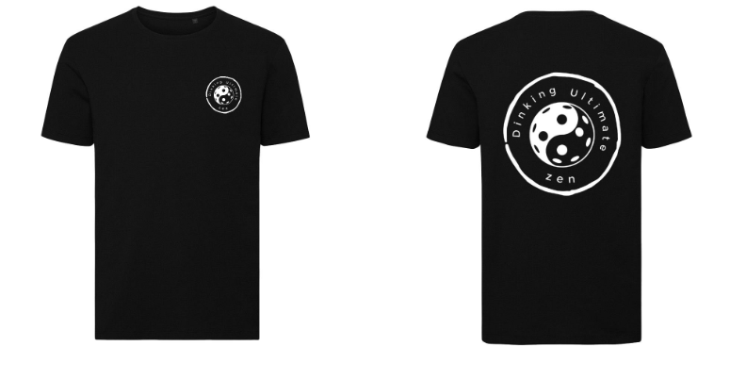
‘The Kitchen’ t-shirt
Printing on left chest
Colours available: white
£20

‘Retro Pickleball’ t-shirt
Printing on left chest and back
Colours available: white, pink
£20

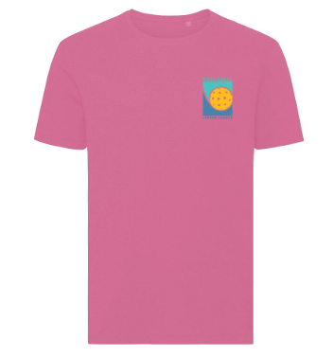
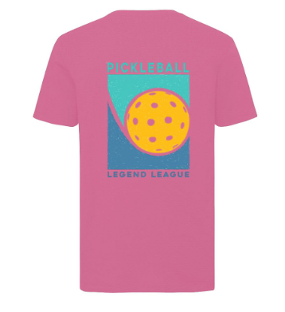
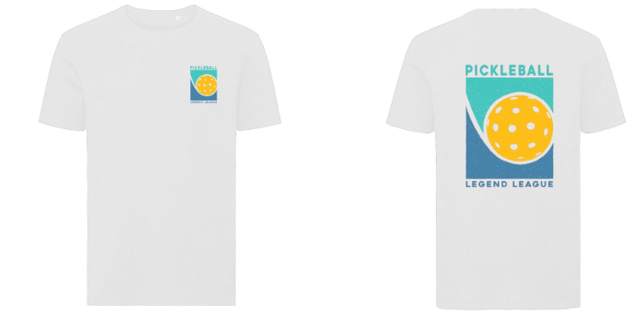

‘Pickleball court’ t-shirt
Printing on left chest
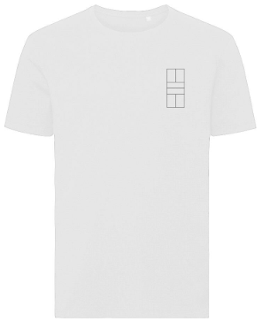
Colours available: white, pink
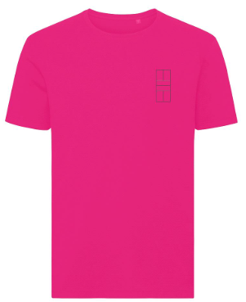
£20

‘Pickleball Department’ t-shirt
Printing on left chest
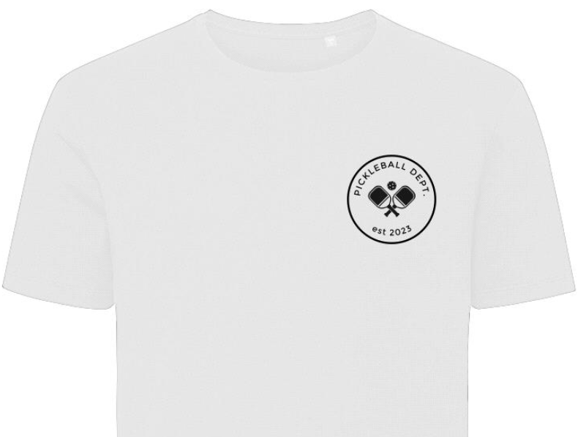
Colours available: green, white
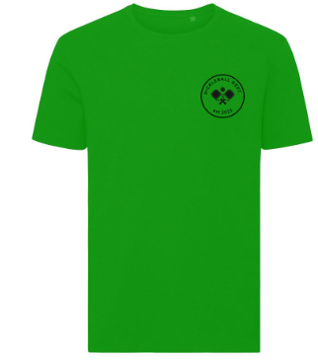
£20
‘Eat. Sleep. Pickleball. Repeat.’ t-shirt
Printing on left chest and back
Colours available: black, navy
£20
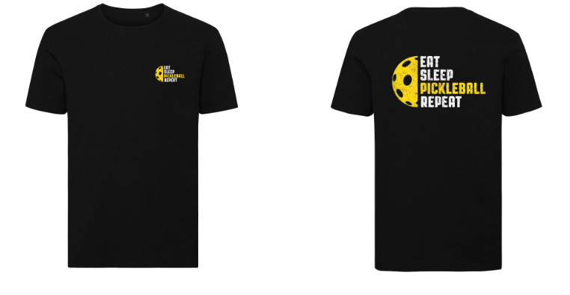
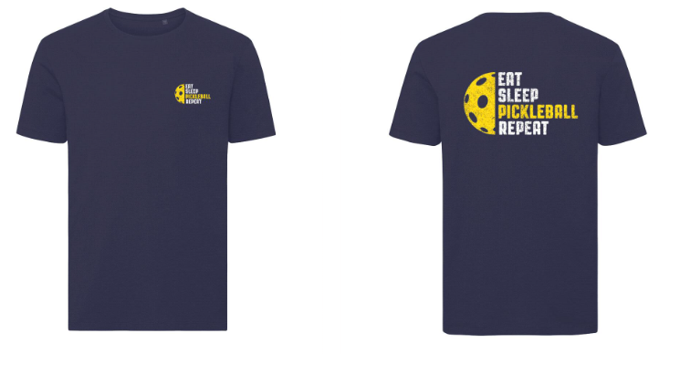

‘Zero Zero Two’ t-shirt
Printing on left chest and back
Colours available: purple, black
£20

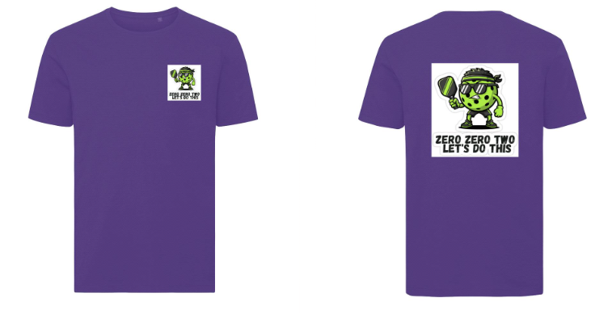

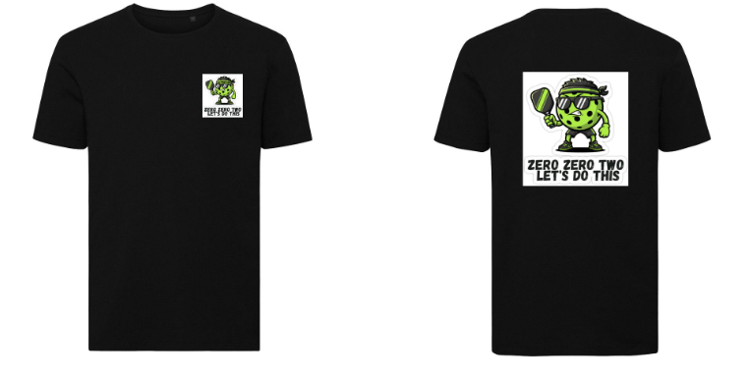
Tote bag – heritage logo
Printing on one side
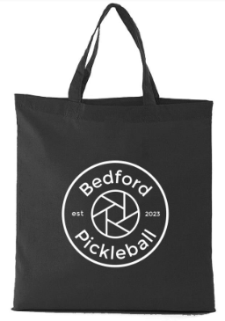
Colours available: black, cream
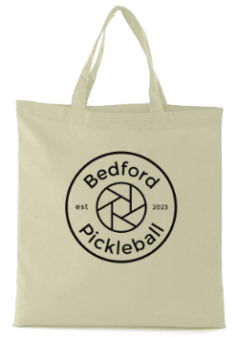
£12

Tote bag - ‘Eat. Sleep. Pickleball. Repeat.’
Printing on one side
Colours available: navy, black
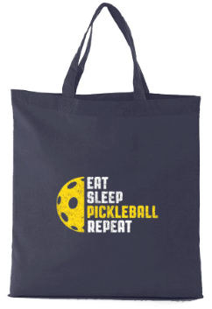
£12
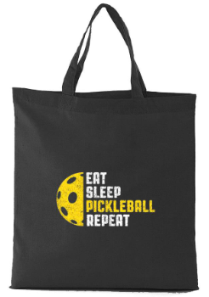

‘Heritage’ cap / ‘BPB Mascot’ cap (adjustable back strap)
Printing on front
Colours available: black / blue
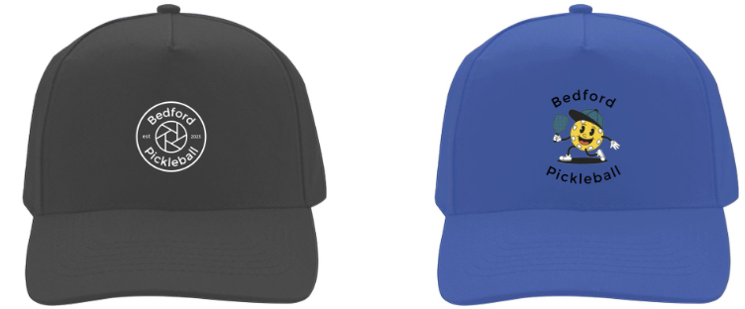
£18

Rugby shirt
Printing on left chest and back
Colours available: black, bottle green
£40
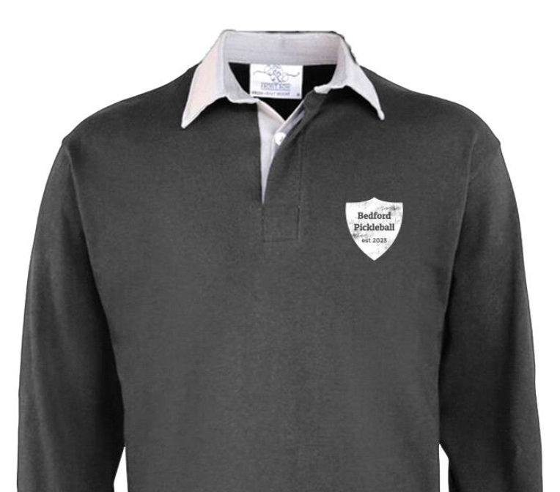
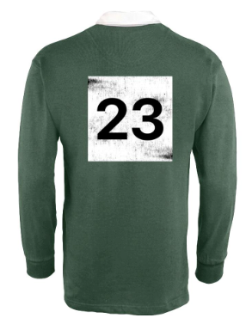

Size guide
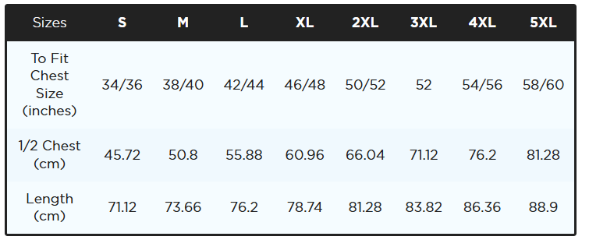
T-shirts (Materials: 100% Cotton

Sweatshirt (Materials: 20% Polyester / 80% Cotton)
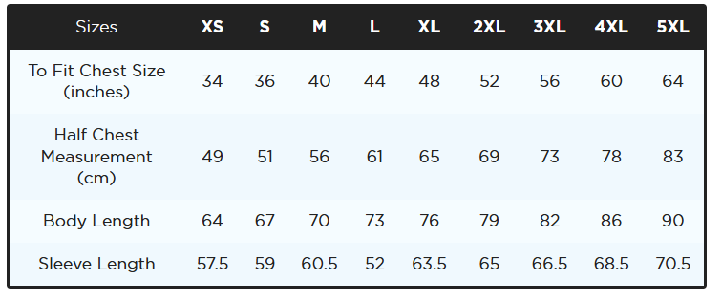
Quarter zip sweater (Materials: 65% Cotton / 35% Polyester)
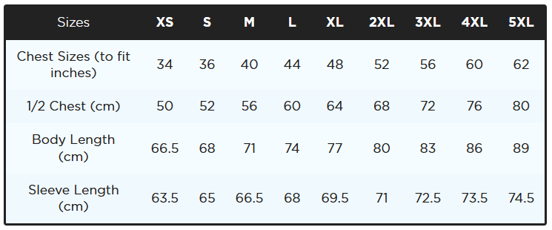

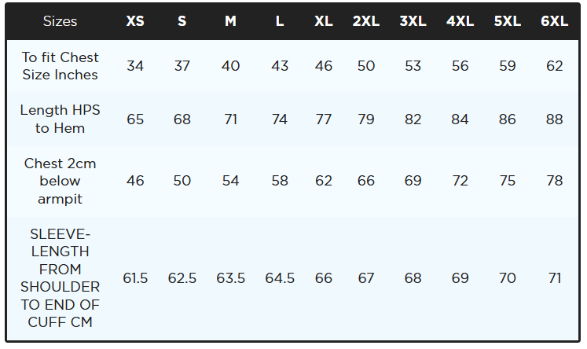
Hoodie (Materials: 80% Cotton / 20% Polyester)

Rugby shirt (Materials: 100% Cotton)
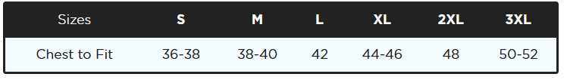

How to order

- email info@bedfordpickleball.co.uk

- In the email include:

- The name of the item(s) found in bold on each page
- Quantity
- Size(s)

- You will be emailed back with a total cost of the items and the account details to transfer this to. This email will serve as a receipt

- Please note, refunds can not be given as they are custom items

Delivery you can collect your items at a Bedford Pickleball session or postage can be arranged for an extra fee (cost dependent on the quantity of items

